Illness Many years ago, a boy in Ohio got cancer. He had to stop going to school. He underwent chemotherapy and the cancer stopped growing. So the boy could go back to school. He was really embarrassed though. He had lost all his hair with the therapy. His friends told him to come anyway. He did, but he still felt so embarrassed when he reached the classroom door. Until he went in. Then it was okay. Eight other boys had shaved their heads too, so that he wouldn’t feel alone.
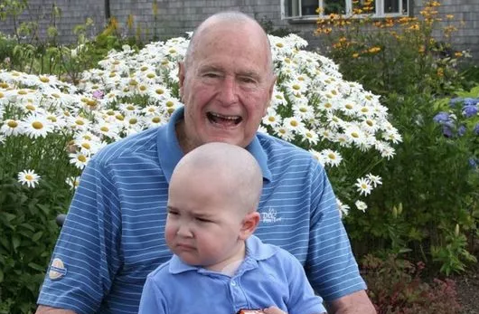
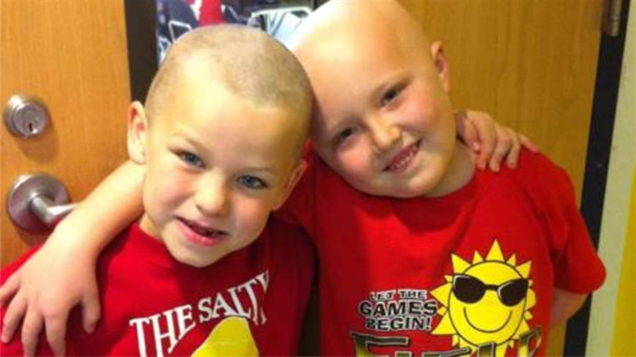
That story became famous. Since then, thousands of people have shaved their heads in support of a child with cancer, including a seven-year-old boy, including a US president.

Motherhood It is hard for mothers with babies to do anything and almost impossible for them to go to school. One woman tried anyway, taking her baby son to class with her. She was mortified when the baby started crying and disrupting the class. The professor stopped, looked at the noisy child, and then the mother. She got ready to leave. Then, the professor walked over, picked the little boy up and calmed him down. He continued his lecture, holding the baby. He didn’t want that embarrassed mother to have to miss the lesson.
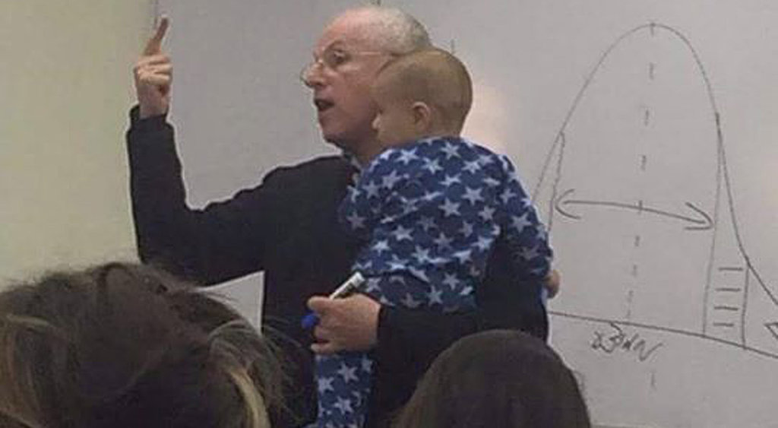
I learned these stories from Curtis Kelly.
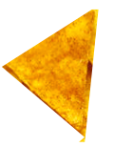
Eating a tortilla chip
with mindfulness.
Read this slowly. Give people time to really notice what they are doing with each step. Pause when you see the dots (•).
You are going to eat a taco chip with mindfulness.
First, pick up a chip. Look at it closely. Imagine you have never seen this before. Really look. (•) Notice the red powder. That’s probably the spice. I wonder if, when the chips are baked, they all become slightly different, like snowflakes or finger prints. (•)
Now bring it to your nose. Breathe in. Smell the flavor. (•) Can you notice the spice? (•)
Now feel what it feels like to break off a piece. Put the piece in your mouth but don’t chew it yet. Just put it on your tongue. (•) Feel what it feels like sitting on your tongue. Notice your mouth getting wet with saliva. Your brain knows, “something good is coming.” (•)
Notice the spicy flavor. Notice how you are enjoying the taste. (•)
Now bite off another piece. Notice the sound as you do. (•)
Eat the rest of the chip like this – as slowly as possible. Enjoy.

